# PLANNED KIELDER RELEASE DATES AND TIMES

**2023**

**Introduction**

This document contains the **proposed** dates and times of Kielder releases for 2023. Users are advised to check [www.tynereleasekielder.co.uk](http://www.tynereleasekielder.co.uk) to ensure they have the most up to date release information. This website is developed and maintained by the hydro power operator and includes information on the reservoir level, the current release zone and the releases for the next 10 days. The operator aims to update the information on a Friday morning, though this may not always be possible. It is now possible to sign up to receive automatic updates whenever the release schedule is changed - please see the website for further details on how to do this.

The Environment Agency has the right to make changes to the programme without prior notice. Any changes will be communicated via the website above, on a best endeavours basis.

The present situation

The revised release regime, trialled from November 2016 to October 2017 and adopted in 2018 will be followed in 2023. This regime aims to: create more storage in Kielder reservoir in the autumn and winter to absorb high inflows; release more variable flows to support the ecology and generate more renewable energy through the hydro power turbines.

Figure 1 below compares the long term average reservoir storage from 1982 to October 2016 with the average storage since November 2016 and shows that the revised regime has been successful in reducing the reservoir storage in the autumn and winter.

Figure 1: comparison of reservoir storage pre and post the 2016 changes

Since the end of 2017 the main turbine has been able to release a wide range of flows from 3.5 to 16 m3/sec, instead of a small number of fixed flows. The details of the release profiles are available on the website above.

Figure 2 below shows the 15 minute flows released in 2022 (on the left) and those released in 2013. A comparison of the two graphs shows how the releases to the North Tyne have been more varied and less ‘blocky’ since the revised regime was implemented.

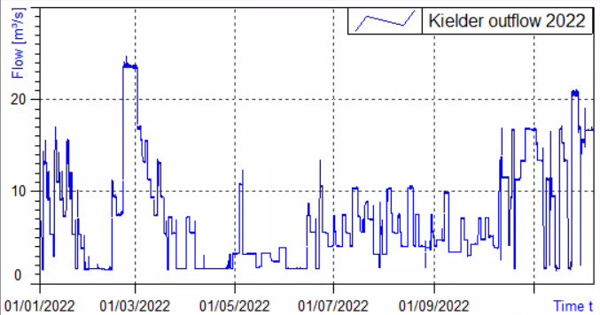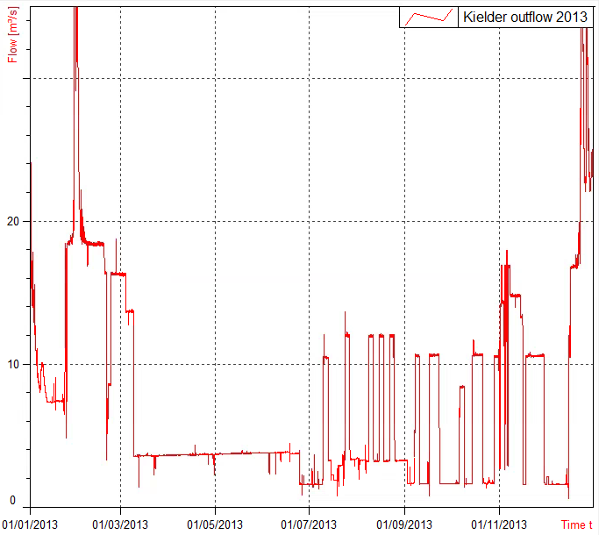

*Figure 2: Kielder releases in 2022* *and 2013*

The release programme will take full advantage of the higher weekday pool tariff prices during the months of November to March inclusive (highlighted in blue on the enclosed table). This means that during these months the start day of all Kielder releases will take place on a Monday at 7am so that peak generation is achieved by the peak demand period at around 9am. During November to February an additional 3 m3/sec (up to the maximum generation flow of 16.8 m3/sec) may be released from 4pm to 7pm during week days to capture peak demand tariff prices.

For the remainder of the year the HEP release pattern will return to the rolling programme, as previously adopted. This means that HEP releases will, as much as possible, start on different days in successive weeks. Except when abstractions are planned, HEP start times will be successively 07.00, 13.30, 19.30, 07.00 and so on. This is to enable each section of the downstream river to experience rising and falling flow conditions on different days and times of the week.

**Releases are made according to this timetable ONLY when** **the agreed policy model shows that** **water is available to be released** (judged according to reservoir level, time of year and current weather patterns).

Release times and days have been altered from June to October to coincide with high tides (indicated in bold on the table). This attempts to encourage the upstream migration of salmonid fish out of the upper estuary where oxygen levels can be depleted during warm summer months. During these weeks releases will be made the day before the high tide is expected in the estuary. Five of these releases were required from mid-June to the beginning of September this year due to high river temperatures, low dissolved oxygen levels and low flows and were successful in encouraging fish past our fish counter at Riding Mill.

One change to the programme adopted in 2021 and to be continued in 2023 is to restrict the maximum release at the end of October to 10 m3/sec unless the reservoir is almost full. This may improve fishing conditions in the upper North Tyne during the last week of the fishing season.

Releases will continue to be amended at the beginning of November to assist in the Environment Agency’s programme of brood stock collection for the Kielder salmon hatchery.

**Other releases**

In the light of competing demands for regulation releases, the Environment Agency can only respond to other requests for releases from recognised organisations and **NOT** from individuals. These requests must be submitted to the Environment Agency as early as possible.